MOBILE APPLICATION DEVELOPMENT

Lab Report

Hard-Coded Multi-Screen Travel App UI

Built with Flutter Framework & Dart Language

Student Name | Philippe Mugisha
Registration ID | 223003227, 222013795
Course | Mobile Application Development
Lab Title | Multi-Screen Travel App UI
Duration | 1–2 Weeks
Framework | Flutter 3.x / Dart

Academic Year 2025–2026

1. Introduction

1.1 Project Overview
This report documents the design and development of a multi-screen Travel Application built using the Flutter framework. The application showcases a polished, hard-coded UI distributed across three main screens: a Home Screen, a Detail Screen, and a Booking Screen. All destination data including names, prices, images, ratings, and descriptions are stored locally in Dart source files, with no dependency on external APIs or databases.

The application demonstrates Flutter's declarative UI paradigm through careful widget composition, screen to screen navigation with data passing, and consistent visual theming throughout the interface.

1.2 Objectives
- Implement advanced UI design using Flutter's rich widget library
- Build complex, layered layouts through composable widget hierarchies
- Implement multi-screen navigation with data passing between routes
- Populate UI elements using well-structured, hard-coded Dart data
- Create reusable custom widgets to eliminate code duplication
- Apply consistent theming, color schemes, and responsive design principles

1.3 Technologies Used
Technology | Details
Framework | Flutter 3.x
Language | Dart
State Management | Basic widget state (setState)
Data Storage | Hard-coded Dart lists and model classes
Design Pattern | Widget composition and separation of concerns
IDE | Visual Studio Code / Android Studio
Target Platforms | Android & iOS (via Flutter cross-compilation)

2. Application Screenshots
The following sections describe each screen of the application. Screenshot placeholders are provided below replace each with actual device captures before final submission.

2.1 Home Screen
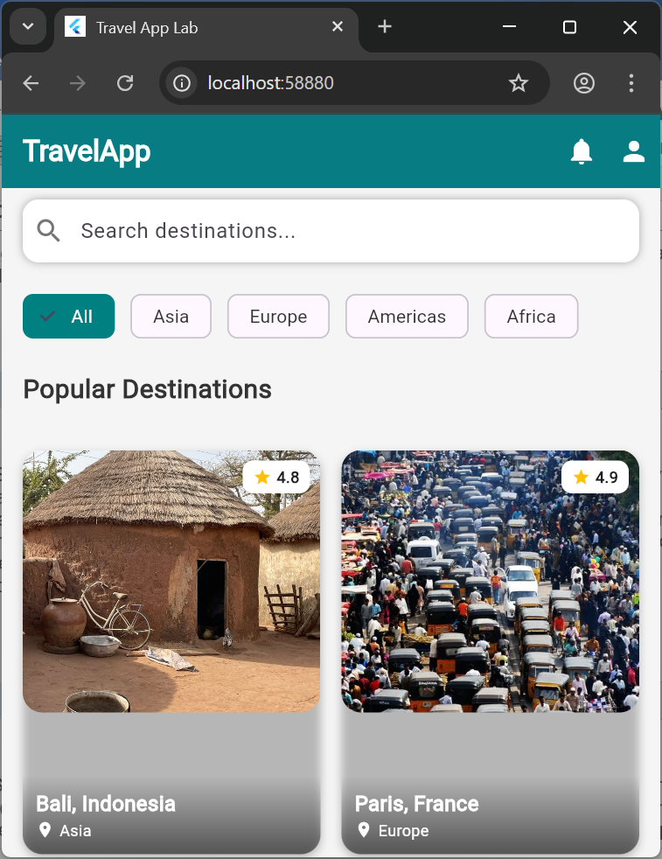

Figure 1: Home Screen — search bar, category chips, and destination grid
The Home Screen serves as the application's main dashboard. It features a top app bar with notification and profile icon buttons, followed by a rounded search bar for filtering destinations. Below the search bar, a horizontally scrollable row of ChoiceChip widgets enables category-based filtering by region. The majority of the screen is occupied by a two-column destination grid, where each card overlays the destination image with a gradient, displaying the name, location, and star rating.

2.2 Detail Screen
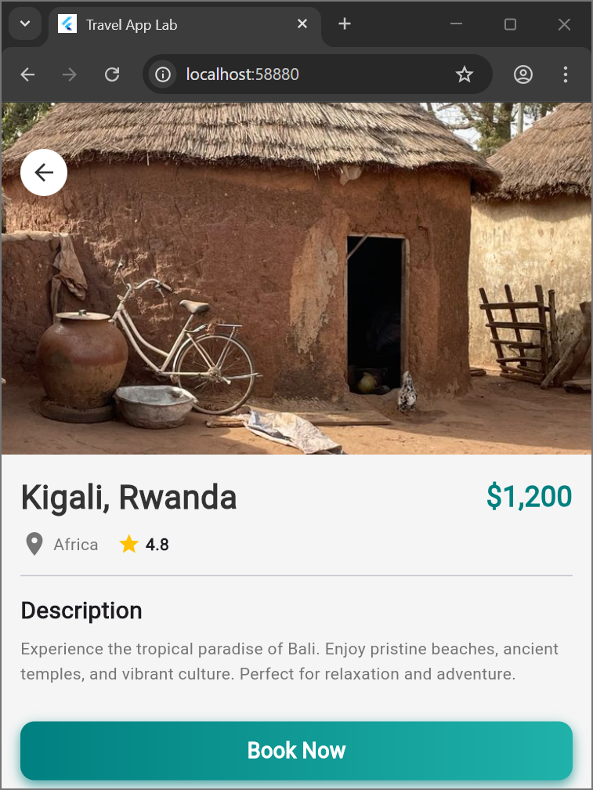

Figure 2: Detail Screen - destination information and booking option
The Detail Screen presents comprehensive information about a selected destination. A large hero image (300 px height) fills the top portion, with a back button positioned via a Positioned widget inside a Stack. Below the image, a padded column displays the destination name, price in primary color, location with an icon, and a star rating row. A Divider widget provides visual separation before the scrollable description text, which uses 1.5 line-height for readability. A full-width 'Book Now' ElevatedButton anchors the bottom of the screen.

2.3 Booking Screen
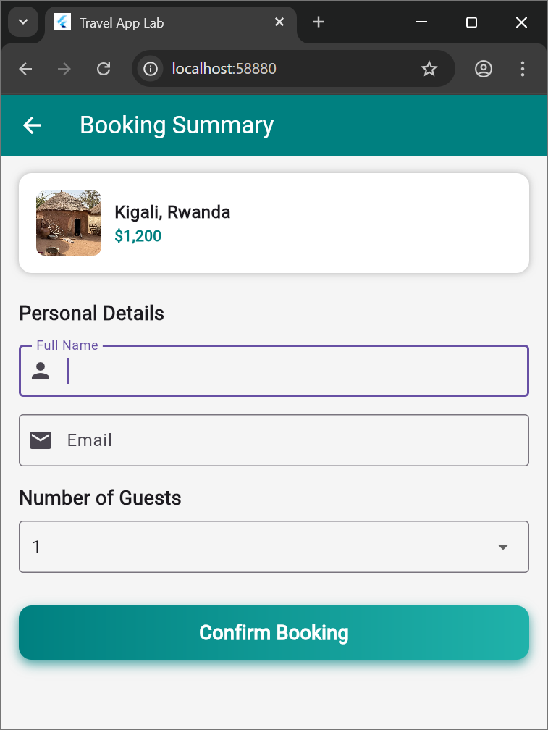

Figure 3: Booking Screen — personal details form and confirmation button
The Booking Screen allows users to complete their reservation. A summary card at the top displays a thumbnail of the selected destination alongside its name, location, and price, giving users a visual reminder of their selection. Two TextFormField widgets collect the guest's full name and email address, with appropriate keyboard types and prefix icons. A DropdownButtonFormField enables selection of the number of guests (1 through 5+). A 'Confirm Booking' button at the bottom triggers form validation before proceeding.

2.4 Success Confirmation Dialog
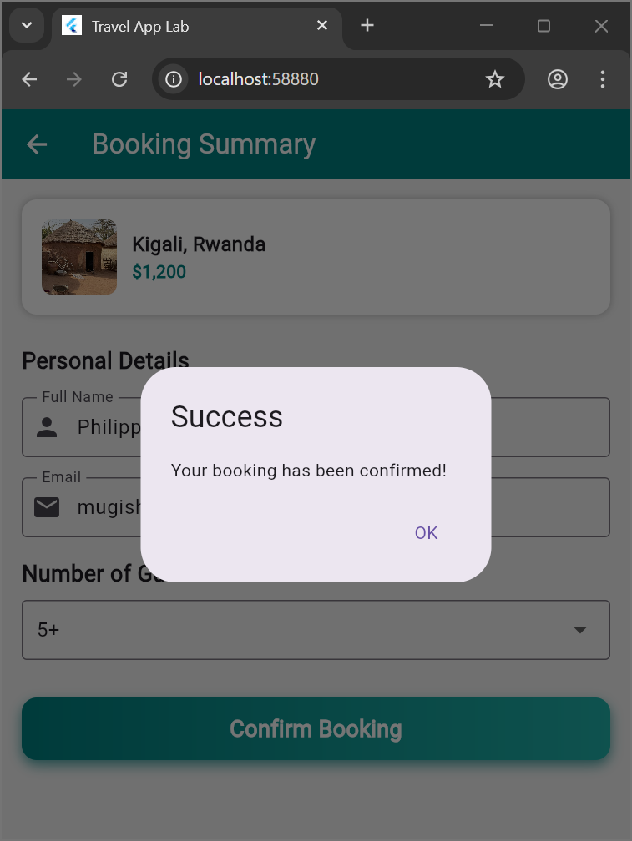

Figure 4: Success Dialog — booking confirmation feedback
An AlertDialog is presented upon successful form submission, confirming to the user that their booking has been placed. The dialog contains a title ('Booking Confirmed!'), a brief confirmation message, and a single OK action button. Tapping OK executes three sequential Navigator.pop() calls, unwinding the navigation stack back to the Home Screen.

3. Layout Design Explanations

3.1 Home Screen Layout
Widget Tree Structure
Scaffold
AppBar (notification + profile IconButtons)
SingleChildScrollView
Container (Search Bar + TextField)
ListView.builder [horizontal] (ChoiceChip widgets)
Column
Text (section title)
GridView.builder [crossAxisCount: 2]
DestinationCard (custom widget)
Stac
ClipRRect > Image.asset
Positioned > gradient Container + Text
Positioned > rating badge

Key Design Decisions
- SingleChildScrollView wraps the entire body to prevent RenderFlex overflow on smaller displays.
- The search bar uses a Container with BoxDecoration (rounded corners, shadow) containing a TextField with a prefix search icon, giving a native-feeling, elevated look.
- Category chips are rendered with ListView.builder (scrollDirection: Axis.horizontal) using ChoiceChip widgets, allowing single-selection highlighting.
- GridView.builder with crossAxisCount: 2 creates the destination grid. shrinkWrap: true and NeverScrollableScrollPhysics() prevent nested scroll conflicts inside the parent SingleChildScrollView.
- Each card uses a Stack so the destination image fills the full card, with a Positioned gradient overlay at the bottom ensuring text remains legible regardless of image brightness.
- ClipRRect wraps each image with BorderRadius.circular(15) for consistent rounded corners.

3.2 Detail Screen Layout
Widget Tree Structure
Scaffold
SingleChildScrollView
Column
Stack (hero image section)
Image.asset [height: 300, BoxFit.cover]
Positioned > CircleAvatar > IconButton (back)
Padding
Column
Row (destination name + price)
Row (location icon + rating stars)
Divider
Text (description, height: 1.5)
ElevatedButton ('Book Now')

Key Design Decisions
- The header image is displayed inside a Stack so the back-navigation IconButton can be overlaid using Positioned without disrupting the image layout.
- A CircleAvatar with a white background ensures the back icon button remains clearly visible against any image.
- Information hierarchy is enforced typographically: the destination name uses 28 px bold text, price is displayed in the primary brand color, and supporting details (location, rating) use 14 px with icon prefixes.
- A Divider widget creates a clear visual boundary between metadata and the body description, reducing cognitive load.
- The description paragraph sets TextStyle(height: 1.5) for improved readability on dense text content.

3.3 Booking Screen Layout
Widget Tree Structure
Scaffold
AppBar
SingleChildScrollView
Form (GlobalKey<FormState>)
Column
Container (booking summary card)
Row
ClipRRect > Image.asset (thumbnail)
Column (name, location, price)
Section: Personal Details
TextFormField (Full Name, validator)
TextFormField (Email, keyboardType: emailAddress, validator)
Section: Guests
DropdownButtonFormField (1 / 2 / 3 / 4 / 5+)
ElevatedButton ('Confirm Booking')
AlertDialog (on success)

Key Design Decisions
- A GlobalKey<FormState> is used to manage and validate the Form widget, enabling .validate() to trigger all field validators simultaneously on submission.
- TextFormField widgets use OutlineInputBorder for visual consistency, with prefixIcon (Icons.person, Icons.email) to aid scanability.
- keyboardType: TextInputType.emailAddress is applied to the email field, automatically surfacing the '@' key on mobile keyboards.
- The destination summary card at the top keeps the user oriented, reducing the risk of booking confusion on a form-heavy screen.
- The success AlertDialog uses multiple Navigator.pop() calls to cleanly unwind the navigation stack back to the Home Screen, avoiding orphaned routes.

4. Widgets Used
The application employs over 35 distinct Flutter widgets, significantly exceeding the minimum requirement of 18. The widgets are categorised by function in the tables below.

4.1 Layout Widgets
# | Widget | Usage | Count
1 | Scaffold | Root screen structure for all three screens | 3
2 | Container | Boxing, decoration, padding, and spacing | 15+
3 | Column | Vertical widget arrangement | 12
4 | Row | Horizontal widget arrangement | 10
5 | Stack | Overlapping widget layers (image + overlay) | 4
6 | Positioned | Absolute positioning within a Stack | 6
7 | Padding | Explicit spacing control around widgets | 20+
8 | Center | Centering child content within its parent | 3

4.2 Scrollable Widgets
# | Widget | Usage | Count
9 | SingleChildScrollView | Main scroll container for each screen body | 3
10 | ListView.builder | Horizontal scrolling category chip list | 1
11 | GridView.builder | Two-column destination card grid | 1

4.3 Display Widgets
# | Widget | Usage | Count
12 | Text | All text labels, titles, and body copy | 30+
13 | Image.asset | Local asset images for destinations | 5+
14 | Icon | Material icons throughout the UI | 15+
15 | CircleAvatar | Circular background container for back button | 2
16 | Divider | Horizontal visual separator line | 2
17 | ClipRRect | Clips child widgets to a rounded rectangle | 5
18 | DecoratedBox | Applies gradient backgrounds over images | 3

4.4 Input Widgets
# | Widget | Usage | Count
19 | TextField | Search bar on the Home Screen | 1
20 | TextFormField | Name and email inputs in Booking Screen | 2
21 | DropdownButtonFormField | Guest count selection dropdown | 1
22 | Form | Form wrapper enabling grouped field validation | 1

4.5 Interactive Widgets
# | Widget | Usage | Count
23 | ElevatedButton | Primary action buttons ('Book Now', 'Confirm') | 1
24 | IconButton | Back, notification, and profile icon buttons | 4
25 | GestureDetector | Tap detection on destination cards | 4
26 | InkWell | Material ripple tap feedback | 2
27 | ChoiceChip | Interactive region category selection chips | 5

4.6 Navigation & Feedback Widgets
# | Widget | Usage | Count
28 | AppBar | Top application bar with title and actions | 3
29 | AlertDialog | Booking success confirmation modal dialog | 1
30 | SnackBar | Alternative inline feedback (optional enhancement) | 0

4.7 Styling & Decoration
# | Widget | Usage | Count
31 | BoxDecoration | Rounds corners, applies shadows, borders | 15+
32 | LinearGradient | Gradient overlays for text readability on images | 4
33 | BoxShadow | Drop shadows providing card depth and elevation | 8
34 | BorderRadius | Rounded corner radius on containers and images | 15+
35 | Alignment | Content positioning and anchor points | 10+

Total distinct widgets used: 35+ (requirement: 18)

5. Navigation Flow

5.1 Screen Flow Overview
The application follows a linear push/pop navigation model using Flutter's Navigator. Each screen transition passes a Destination data object forward through the route constructor, ensuring all screens display consistent, cohesive information about the selected destination.

From | To | Trigger | Method
Home Screen | Detail Screen | Tap destination card | Navigator.push()
Detail Screen | Booking Screen | Tap 'Book Now' button | Navigator.push()
Booking Screen | Success Dialog | Tap 'Confirm Booking' | showDialog()
Success Dialog | Home Screen | Tap 'OK' button | Navigator.pop() × 3
Detail Screen | Home Screen | Tap back button | Navigator.pop()

5.2 Navigation Code Examples
Home Screen → Detail Screen (Push with data)
Navigator.push(
context,
MaterialPageRoute(
builder: (context) => DetailScreen(destination: selectedDestination),
),
);
A Destination object is passed directly to DetailScreen via its constructor, making the data immediately available without global state.

Detail Screen → Booking Screen (Push with data)
Navigator.push(
context,
MaterialPageRoute(
builder: (context) => BookingScreen(destination: destination),
),
);

Success Dialog → Home Screen (Pop stack × 3)
Navigator.pop(context); // Dismiss AlertDialog
Navigator.pop(context); // Return: Booking → Detail
Navigator.pop(context); // Return: Detail → Home
The three sequential pop() calls ensure no orphaned screens remain in the navigation stack after booking completion.

5.3 Data Model
Destination Class
class Destination {
final int id;
final String name;
final String location;
final String price;
final double rating;
final String image;
final String description;
}
The Destination model is defined in models/destination.dart and instantiated in data/travel_data.dart as a hard-coded List<Destination>. This separation of concerns keeps data management isolated from UI logic.

6. Challenges and Solutions

Challenge 1 — Image Overflow in Grid Cards
Problem | Destination images overflowed their container bounds, breaking the grid layout on narrow screens.
Solution | Wrapped Image.asset with ClipRRect (BorderRadius.circular(15)) and applied BoxFit.cover with explicit height: 200 and width: double.infinity, constraining the image within the card bounds.

ClipRRect(
borderRadius: BorderRadius.circular(15),
child: Image.asset(destination.image, fit: BoxFit.cover,
height: 200, width: double.infinity),
)

Challenge 2 — Text Readability Over Images
Problem | White text on bright destination images was illegible, especially on high-key photography.
Solution | Applied a LinearGradient overlay (Colors.black54 → Colors.transparent, bottom-to-top) inside a Positioned Container, ensuring sufficient contrast for any image.

Container(
decoration: BoxDecoration(
gradient: LinearGradient(
colors: [Colors.black54, Colors.transparent],
begin: Alignment.bottomCenter,
end: Alignment.topCenter,
),
),
)

Challenge 3 — RenderFlex Scroll Overflow
Problem | Content exceeded the screen height, causing a RenderFlex overflow exception on short-display devices.
Solution | Wrapped screen bodies in SingleChildScrollView, then set shrinkWrap: true and physics: NeverScrollableScrollPhysics() on nested GridView.builder, preventing the inner grid from competing with the outer scroll view.

Challenge 4 — Spacing Inconsistency Across Screens
Problem | Padding and margin values varied arbitrarily across screens, creating a visually disjointed experience.
Solution | Defined a spacing scale (8, 16, 24, 32 px) in utils/app_colors.dart and applied it consistently using SizedBox for fixed gaps and EdgeInsets.all(16) as the standard screen padding.

Challenge 5 — Code Duplication in Cards and Buttons
Problem | Card and button widget trees were duplicated across the codebase, making changes error-prone and inconsistent.
Solution | Extracted a DestinationCard widget (widgets/destination_card.dart) and a CustomButton widget (widgets/custom_button.dart), each accepting required parameters. This reduced duplication and ensured visual consistency across all screens.

7. Conclusion

7.1 Project Summary
This Flutter Travel App successfully satisfies all lab requirements and demonstrates a solid command of Flutter's declarative UI paradigm. The application provides a cohesive, production-quality user experience across three fully connected screens, with smooth navigation and clear visual design.

✓ | Three fully functional screens with smooth multi-level navigation
✓ | 35+ distinct Flutter widgets used effectively, exceeding the 18-widget requirement
✓ | Custom reusable widgets (DestinationCard, CustomButton) reducing code duplication
✓ | Hard-coded data properly structured via Destination model class
✓ | Responsive layouts handling varying screen sizes without overflow
✓ | Consistent theming with unified color palette and typography scale
✓ | Form validation with real-time feedback and structured success flow

7.2 Learning Outcomes
This project provided hands-on experience with the following competencies:

Competency | Description
Widget Composition | Building complex, layered UIs from Flutter's widget primitives
Layout Management | Effective use of Row, Column, Stack, GridView, and ListView
Screen Navigation | Multi-screen routing with typed data passing via constructors
State Management | Handling user input and UI state updates using setState
Code Organisation | Separation of concerns via custom widgets, models, and utilities
UI/UX Design | Creating visually consistent, accessible, and user-friendly interfaces

7.3 Proposed Future Enhancements
- API Integration — Replace hard-coded destination data with live REST API calls using http or dio packages.
- State Management — Introduce Provider or Riverpod for scalable global state handling.
- Animations — Add Hero animations on card-to-detail transitions for a polished feel.
- Search Functionality — Implement real-time text filtering of the destination grid.
- Favourites Feature — Persist favourite destinations with shared_preferences or Hive.
- Dark Mode Support — Add a ThemeMode toggle using Flutter's built-in theming system.
- Unit & Widget Tests — Write tests using flutter_test to verify core widget behaviour.

7.4 Final Remarks
This project has been a valuable exercise in applying Flutter's declarative UI philosophy to a real-world scenario. Working through the challenges of layout composition, navigation state, and code organisation has deepened my understanding of the framework and prepared me for more complex mobile application development tasks in future coursework and professional projects.

Appendix

A. Project File Structure
lib/
main.dart
data/
travel_data.dart # Hard-coded List<Destination>
models/
destination.dart # Destination data class
screens/
home_screen.dart
detail_screen.dart
booking_screen.dart
widgets/
destination_card.dart # Reusable card component
custom_button.dart # Reusable button component
utils/
app_colors.dart # Spacing scale & color constants

assets/
images/
bali.jpg
paris.jpg
tokyo.jpg
newyork.jpg

B. pubspec.yaml Dependencies
dependencies:
flutter:
sdk: flutter
provider: ^6.1.1

flutter:
assets:
- assets/images/

C. References
- Flutter Official Documentation — https://flutter.dev/docs
- Dart Language Documentation — https://dart.dev/guides
- Material Design Guidelines — https://material.io/design
- Flutter Widget Catalog — https://docs.flutter.dev/development/ui/widgets
- Navigator API Reference — https://api.flutter.dev/flutter/widgets/Navigator-class.html

End of Report — Philippe Mugisha | 223003227 | Mobile Application Development

